CSA1505 - CLOUD COMPUTING AND BIG DATA ANALYTICS
Experiment-10

10. Create a simple cloud software application to run a c program to display the student information using any Cloud Service Provider to demonstrate SaaS with the template of student name, reg no, address, phone, age, courses, grades and attendance report, progress report, Semester mark sheet forms

AIM:
To develop a simple Student Information System using Zoho Creator (Cloud Service Provider) to demonstrate the Software as a Service (SaaS) model. The application stores student information, attendance, grades, progress reports, semester mark sheets, and a C program related to student information.
PROCEDURE:
- Log in to Zoho Creator.
- Create a new application named Student Information System.
- Design a form with fields for student name, register number, address, phone number, age, course, grade, attendance report, progress report, semester mark sheet, C program, and date.
- Configure the required field types and drop-down values.
- Create a workflow to automatically record the current date and time.
- Save and publish the application.
- Enter student details, upload the semester mark sheet, and store the C program.
- Verify that all details are saved successfully.
INPUT:
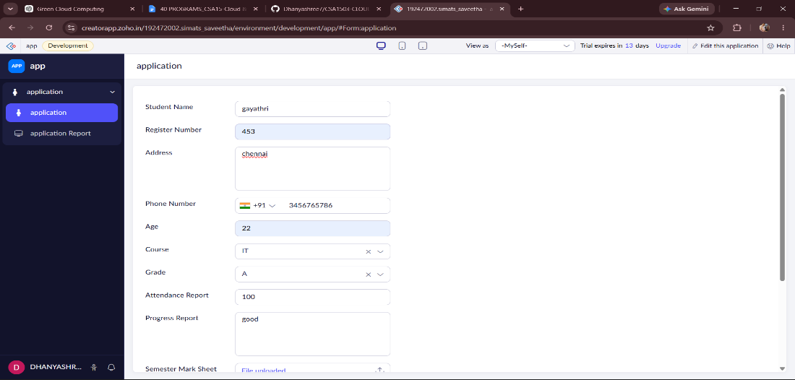
OUTPUT:
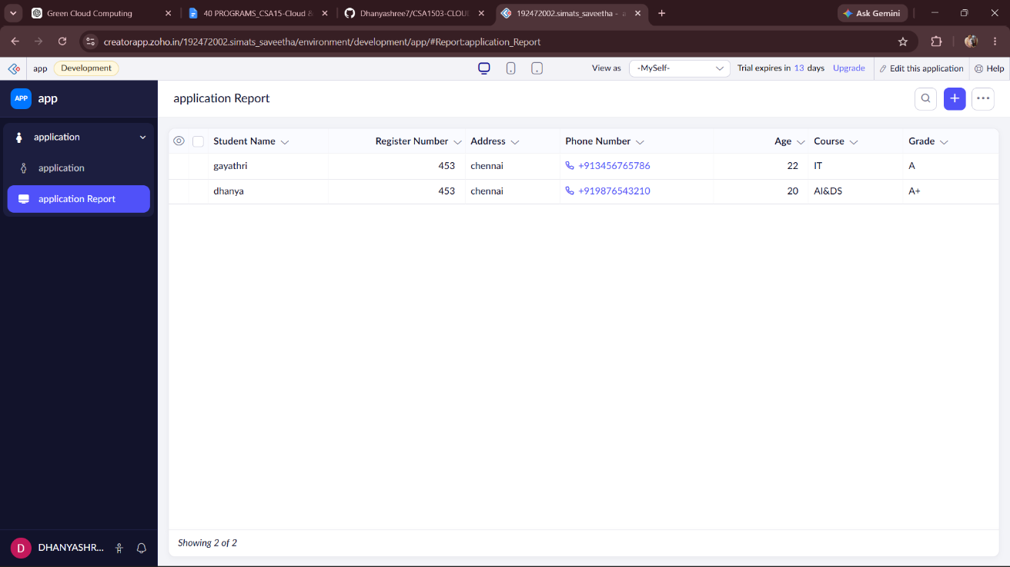
DESIGN:
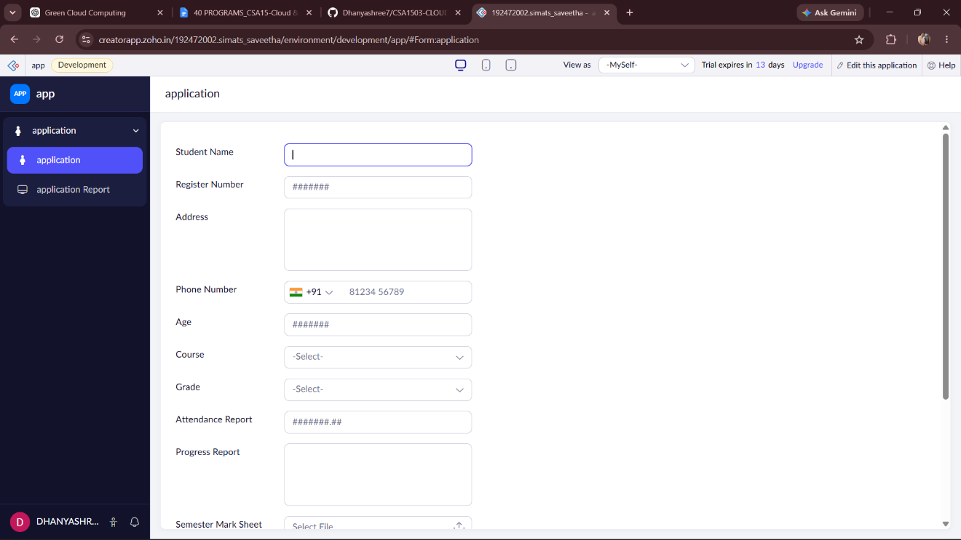

WORKFLOW:
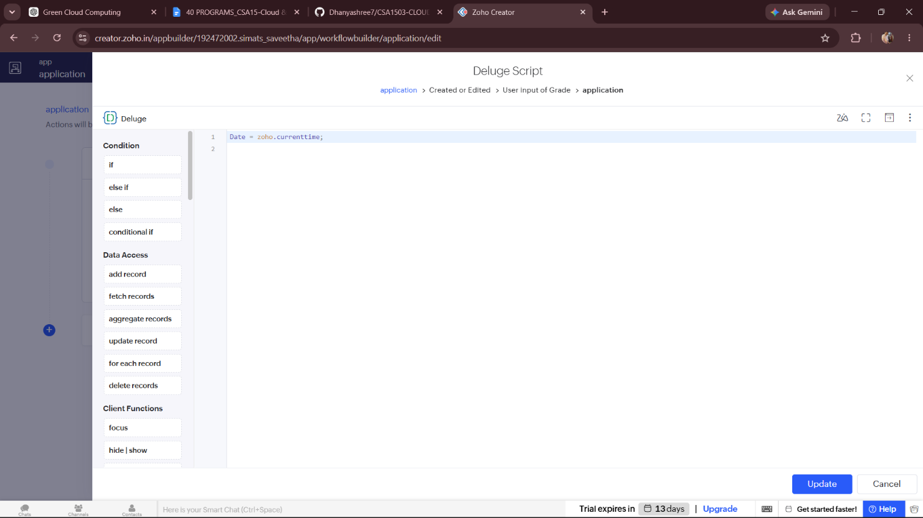
RESULT:
A cloud-based Student Information System was successfully developed using Zoho Creator. The application stores student personal and academic information, attendance records, grades, progress reports, semester mark sheets, and a C program. This demonstrates the implementation of the Software as a Service (SaaS) model using a cloud platform.

